Loan Approval Prediction

Implementation Document

Makerere University, College of Computing and Informatics Sciences

Software Engineering

**Group Members**

|  |  |  |  |
| --- | --- | --- | --- |
| Name | Student Number | Registration Number | Signature |
| Amoko Ivan | 217014453 | 17/U/2680/EVE |  |
| Senfuka Raymond Wilson | 217012016 | 17/U/9982/PS |  |
| Asiimwe Brenda Angel | 217002455 | 17/U/3014/EVE |  |
| Ssemakula Rajab | 217011090 | 17/U/10165/EVE |  |

Date: 24th June 2019

1. **Loan Status Against Other Variables menu**

Loan Status Against Other Variables menu shows how the loan_status (response variable) changes with reference to other variables in the train dataset. This is as shown Below.

1. Loan Status against gender

The male have the largest number of loan approvals and rejections compared to the female

1. Loan Status against married

A larger proportion of not married applicants are refused than married ones

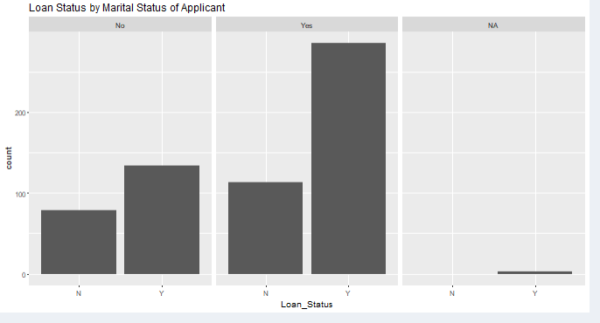

1. Loan Status against Applicant Income

 Shows that low income people are mainly applying for loans and number of loan rejection is more in the lowest income segment

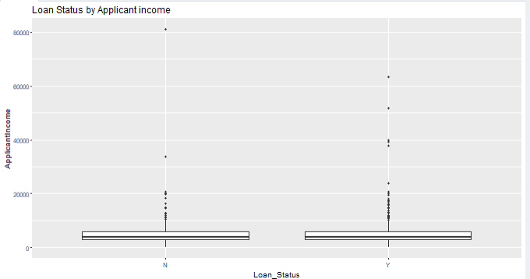

1. Loan Status against Self employed

Not self-employed seems to be slightly preferred to increase on the chances of acquiring a loan

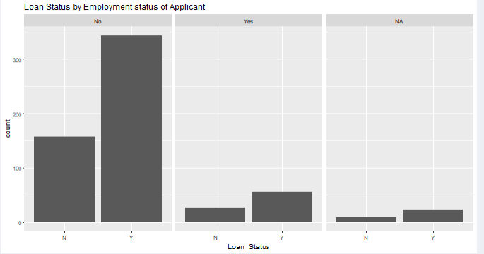

1. Loan Status against Loan Amount Term

Difficult to see any patterns, most of the loans are for 360 months

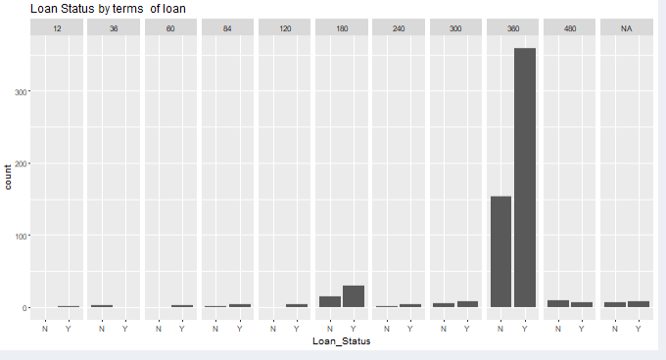

Figure 1:loan status against loan amount term

1. Loan Status against credit_history

Almost all applicants with history=0 are rejected

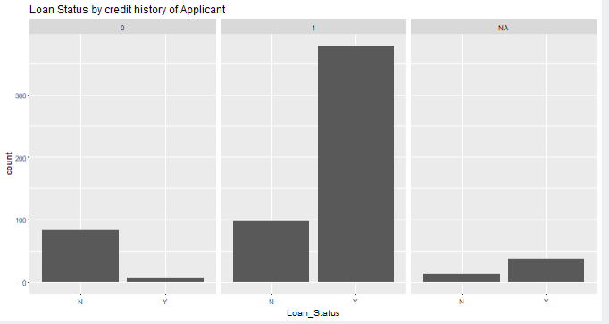

1. Loan Status against Loan Amount

The third quartile of the refused loans is higher

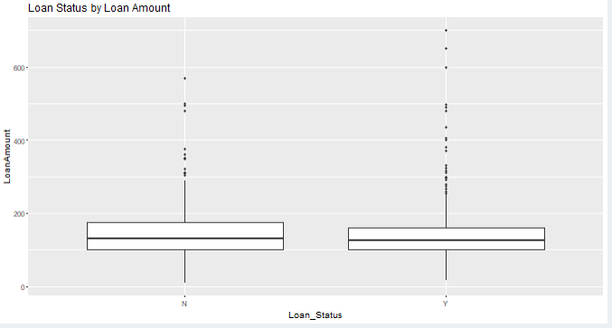

1. Loan Status against Property Area

There are increased chances of getting a loan if the property is semi urban and hardest if it is rural

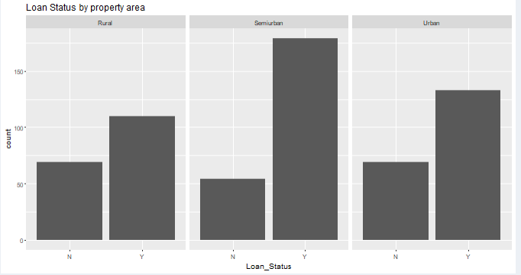

1. Loan Status against CoApplicant Income

Low income people are mainly applying for loans and number of loan rejection is more in the lowest income segment

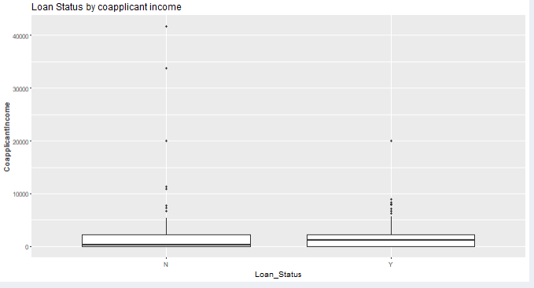

Figure 2:loan status against education

1. Loan Status against Education

A larger proportion on non-graduates are refused than graduates

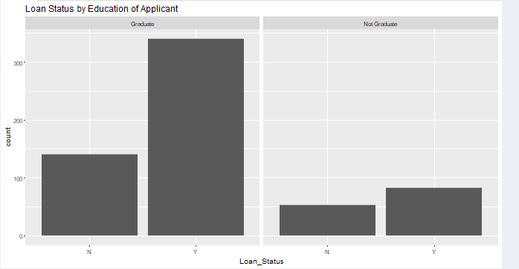

Figure 3:Loan status against education

1. Loan Status against Dependents

A smaller proportion of applicants with 2 dependents is refused than other numbers

